ADTA 5750: Applied Natural Language Processing
Thuan L Nguyen, PhD
Final Project

Conversational AI System: System Design
The Conversational AI System Design of CarToGo
Team: CarToGo (group 6)
Team Members:
- Sonali Sabnam
- Sheba Rani Paladugu
- Rinal Shah
- Rejesh Anne
- Tao Xiong
- Akhila Uppula

Virtual Agent
CarToGo

Flows
In our CarToGo, we only focus on the booking function
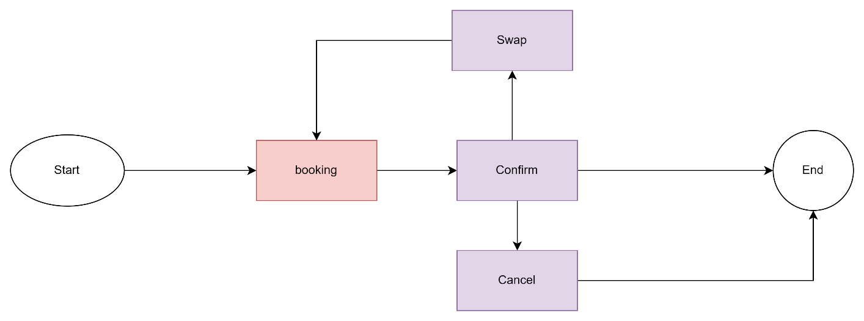

Flows Name | Description
Booking | The Main Flow of the conversational system. It will include
Confirm | This is a subflow of booking that use to confirm the booking process
Swap | This flow can be used for changing the booking.
Cancel | This flow can be used for canceling the booking.

Entities & Entity Types
Entity Types | Entities | Types of Entities | Entity Options
Vehicle_Types | 1.Sedan  2. SUV  3.Van | User-defined | Enum-List
Vehicle_Sizes | 1. Compact  2. Standard  3. Full-Size  4. Premium | User-defined | Enum-List
Seaters | Seaters {a, @sys.number-integer } | @sys.number-integer | Struct-Composite
Pickup_Location | 1. DFW Airport  2. Denton  3. Dallas | user-defined | Enum-List
Pickup_Time | {  "year": integer,  "month": integer,  "day": integer,  "past": {...},  "future": {...},  "partial": {...}  } | @sys.date-time | Enum-List-Map
Drop_off_Location | 1. DFW Airport  2. Denton  3. Dallas | User-defined | Enum-List
Drop_off_Time | {  "year": integer,  "month": integer,  "day": integer,  "past": {...},  "future": {...},  "partial": {...}  } | @sys.date-time | Enum-List-Map
Firstname | String | @sys.person | string
Lastname | String | @sys.person | String
Phone_number | “1234567890” | @sys.phone-number | String
Email | String | @sys.email | String

Intents

Main intent (booking)
booking (Vehicle_Types vehicle_types, Vehicle_Sizes vehicle_sizes, Seaters seaters, Pickup_Location pickup_location, Pickup_Time pickup_time, Drop_off_Location drop_off_location, Drop_off_Time drop_off_time)

Training Phrases
I need a small suv with 5 seats for 3 days from DFW Airport at 3:30 and drop off it at Denton at 3:30
Can I have a 7 seats van from today 12PM to Friday 12PM in DFW Airport, but I would like to return it at Dallas
I would like to book a sedan in Denton next week
What type of car do you have?
Where can I pick up the car?
Where can I drop-off the car?
Pickup location
Drop-off location
I need a van
Which vehicles do you have?
How many vehicles type do you have?
How many seaters in this van?

Data model
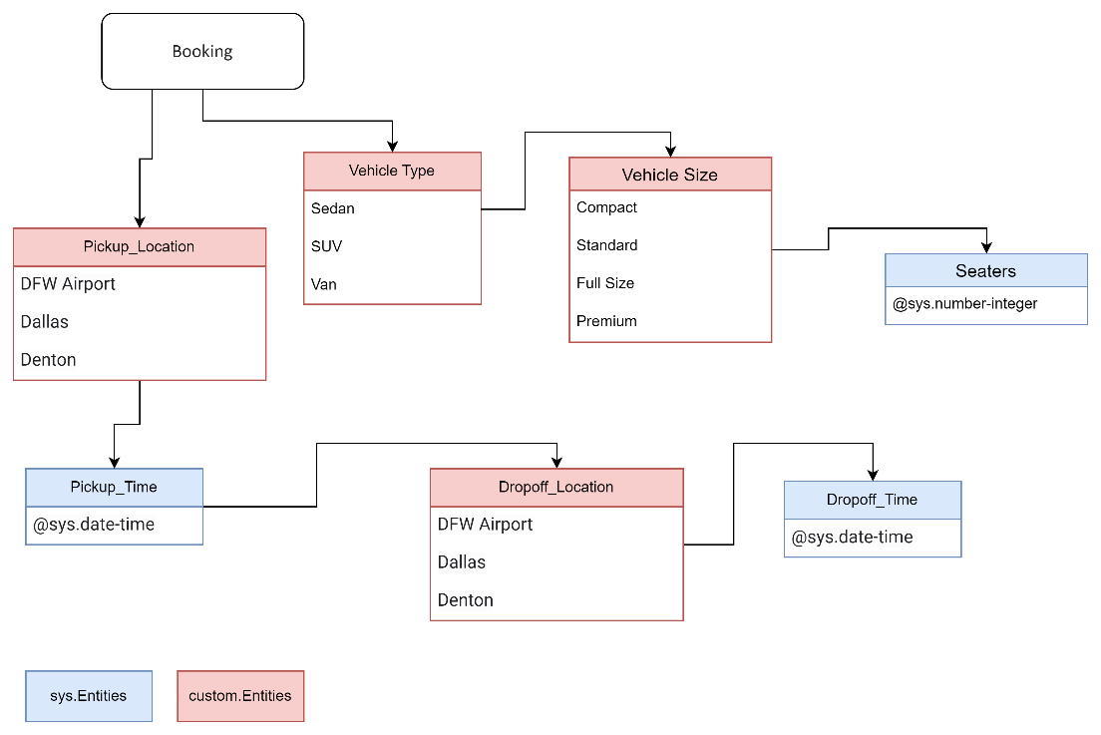
Figure 1 data model of booking intent

Additional Parameters
Confirm (Firstname firstname, Lastname lastname, Phone_number phone_number, Email email)
Note: those parameters are only inside the Customer_info page.
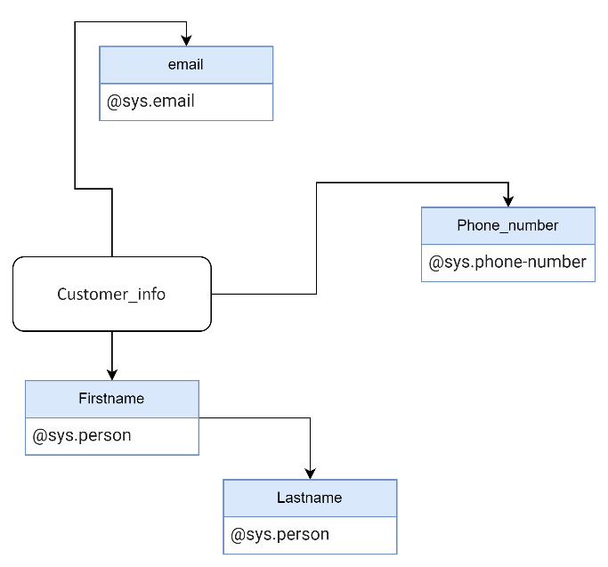
Figure 2 data model of customer_info

Actions
Action Name | Training Phrases
Confirm | Yes
 | Okay
 | Great
 | Ok
 | Yes, confirm
 | Awesome
 | It’s perfect
 | Cool I like that
 | It is grate
 | Confirm
Cancel | No, cancel
 | No
 | I don't need this booking
 | cancel
Swap | Swap the booking
 | change
 | swap
 | I want to swap the pickup location
 | I want to swap the sedan
 | Can I change the SUV to full-size?
 | Can I change my booking?
 | Cool I like that
 | change a car
 | I want to swap my time

State Machine
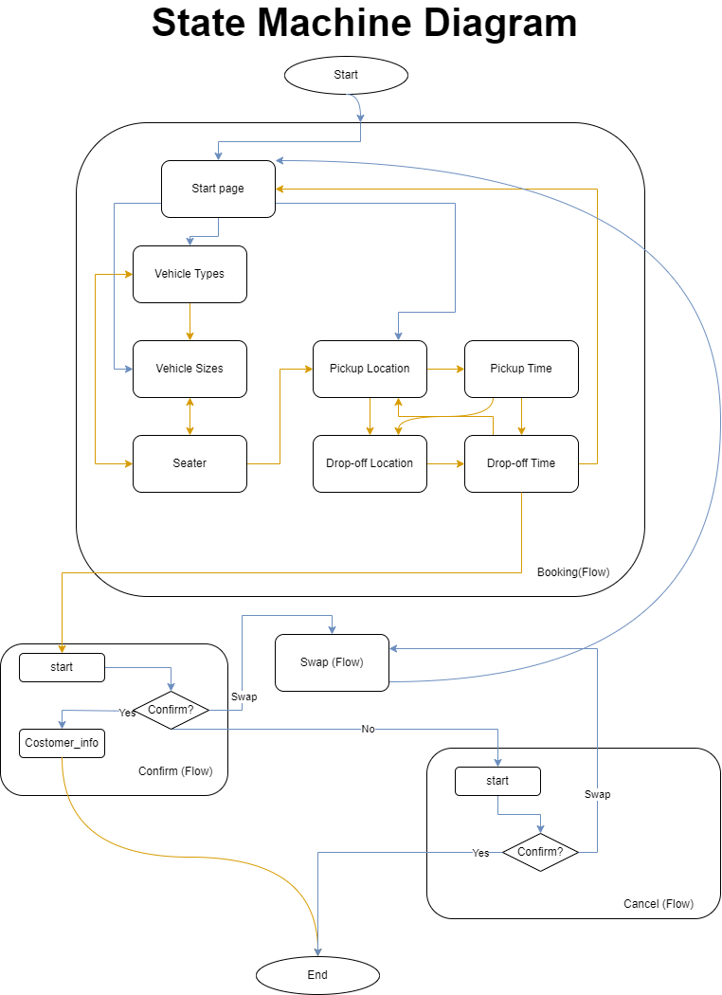

Pages & State Handlers

Intent Routes
Flows | Pages (in Flow) | Routers > Intents | Routes > Transition
Booking | Start | booking | Vehicle_Types
Booking | Start | booking | Vehicle_Sizes
Booking | Start | booking | Pickup_Location
Confirm | Start | confirm | Customer_info
Confirm | Start | swap | Swap (Flow)
Confirm | Start | cancel | Cancel (Flow)
Cancel | Start | confirm | Cancel.confirm
Cancel | Start | swap | Swap (Flow)
Swap | Start | swap | Booking (Flow)

Conditional Routes
Flows | Pages | Conditional Routes | Routes > Transition
Booking | Vehicle_Types | $session.params.Vehicle_Sizes = Null AND $session.params.Vehicle_Types != Null | Vehicle_Size
Booking | Vehicle_Types | $session.params.vehicle_sizes != null AND $session.params.vehicle_types != null | Seaters
Booking | Vehicle_Size | $session.params.vehicle_sizes != null | Seaters
Booking | Seaters | $session.params.vehicle_types = null OR ($session.params.seaters >= 7 AND $session.params.Vehicle_Types != "Van") OR ($session.params.seaters >= 5 AND $session.params.Vehicle_Types != "SUV") | Vehicle_Types
Booking | Seaters | $session.params.vehicle_sizes = null | Vehicle_Size
Booking | Seaters | ($session.params.seaters != Null AND $session.params.seaters <= 5) OR ($session.params.seaters != Null AND $session.params.seaters >= 7 AND $session.params.vehicle_types = "Van") OR ($session.params.seaters != Null AND $session.params.seaters <= 7 AND $session.params.vehicle_types = "SUV") | Pickup_Location
Booking | Pickup_Location | $session.params.pickup_location != Null AND $session.params.Pickup_Time = Null | Pickup_Time
Booking | Pickup_Location | $session.params.drop_off_location = null AND $session.params.pickup_location != null | Drop_off_Location
Booking | Pickup_Time | $session.params.Pickup_Location != Null AND $session.params.Pickup_Time != Null AND $session.params.Drop_off_Location = Null | Drop_off_Location
Booking | Pickup_Time | $session.params.drop_off_location != null | Drop_off_Time
Booking | Drop_off_Location | $session.params.Drop_off_Location != Null AND $session.params.Drop_off_time = Null | Drop_off_Time
Booking | Drop_off_Time | $session.params.Pickup_Location = null | Pickup_Location
Booking | Drop_off_Time | $session.params.Drop_off_Time != null AND $session.params != null AND $session.params.pickup_time != null AND $sys.func.IS_PAST_DATE($session.params.drop_off_time) != True | Confirm (Flow)
Confirm | Customer_info | $page.params.status=”FINAL” | End Session

Conditional Responses
The conditional response was used inside “customer_info” page to provide the store address to the customer who confirmed the booking.
if $session.params.pickup_location = "DFW Airport"
See you at our DFW Airport store (2424 E 38th St, Dallas, TX, 75261, United States) at $session.params.pickup_time
elif $session.params.pickup_location = "Denton"
See you at our Denton store (2324 San Jacinto Blvd, Denton, TX, 76205, United States) at $session.params.pickup_time
elif $session.params.pickup_location = "Dallas"
See you at our Dallas store (1303 Commerce St, Dallas, TX, 75202, United States) at $session.params.pickup_time
endif

